AHII- The Great American West

Westward Migration
- Push Factors-

- Pull Factors-

- Mormons-

- Acts to Encourage Expansion
  - Homestead Act-
  - Morrill Land Grant Act-

Problems for Farmers

- What were some problems farmers faced?
- Explain each solution
  - Sod Homes-
  - Windmills-
  - Steel Plow-
  - Barbed Wire-
- Which invention will put an end to the open range?

Transcontinental Railroad
- Who provided the labor to build the railroad?
- Where did the two railroads meet and connect?
- What impact will the transcontinental railroad have?

Credit Mobilier Scandal
- Briefly explain what happened in the Credit Mobilier Scandal.

- What impact will this have?

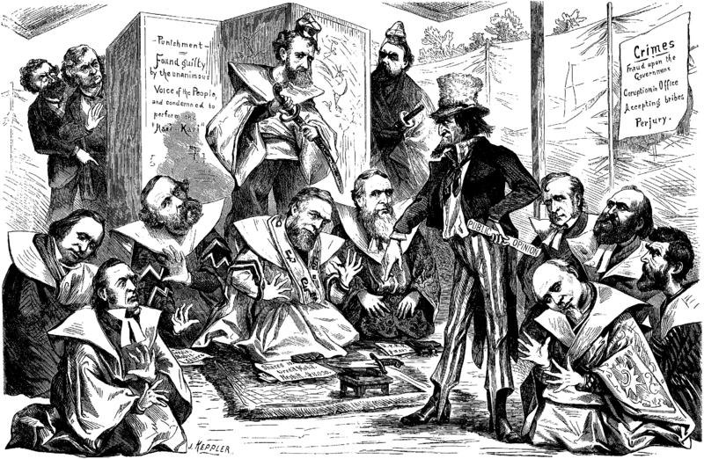
S-

P-

A-

M-

Indians and the Buffalo
- How did the Indians rely on the Buffalo?

- What impact will the destruction of the Buffalo have on the Indians?

Mining and Cattle Boom
- What is a boomtown? Give some examples.

- What is a ghost town?
- What impact will this have on the United States?

- Where did cattle drives take place?
- Who were the Cowboys? What was their life like?

