Westward Migration and the Indians

Review
- What was the Indian Removal Act of 1830?

- What did the US Supreme Court rule in the Worcester v. Georgia case?

- What was the Trail of Tears?

Life of the Plains Indians
- How did life for the Indians change after the Spanish introduced the horse?

- How will the destruction of the Buffalo impact the Indians?

Battle | Description and Significance
Sand Creek Massacre
Battle of
Little Bighorn
Nez Perce and Geronimo
Battle of
Wounded Knee

Other Events

- What was the Bureau of Indian Affairs?

- Who wrote Century of Dishonor? Explain what it was about.

- What was the purpose of the Dawes Act?

- Name 3 ways the Dawes Act will try to accomplish this purpose.

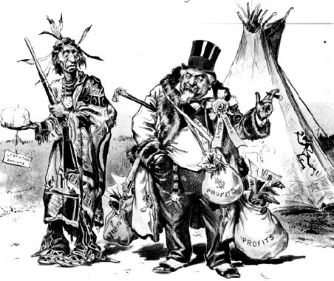

S-__________________________________________
P-__________________________________________
A-__________________________________________
M-_________________________________________

